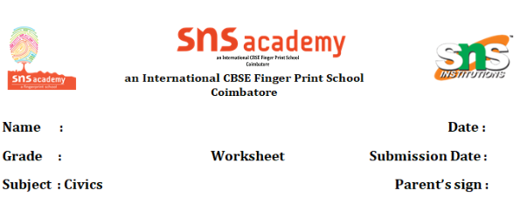 **The Value of work**

**Section A: Multiple Choice Questions.**

**I choose the correct option:**

1. Which of the following is an example of **economic activity**?  
   a) A mother cooking at home  
   b) A teacher teaching in a school  
   c) A child playing in the park  
   d) A person going for a walk
2. What does **non-economic work** mean?  
   a) Work done to earn money  
   b) Work done by machines  
   c) Work done for personal satisfaction  
   d) Work that involves trading
3. Which of the following is a **primary activity**?  
   a) Tailoring  
   b) Fishing  
   c) Teaching  
   d) Driving
4. Making furniture from wood is an example of:  
   a) Primary activity  
   b) Tertiary activity  
   c) Secondary activity  
   d) Non-economic activity
5. Doctors and nurses belong to which type of activity?  
   a) Primary  
   b) Secondary  
   c) Tertiary  
   d) Economic
6. Which of the following is an **economic activity**?  
   a) Gardening in your backyard  
   b) Selling vegetables in the market  
   c) Cleaning your own house  
   d) Studying at home
7. A person who works in a bank is part of the:  
   a) Primary sector  
   b) Secondary sector  
   c) Tertiary sector  
   d) Informal sector
8. The main purpose of **economic activity** is:  
   a) Entertainment  
   b) Relaxation  
   c) Earning income  
   d) Helping friends
9. Growing crops is an example of:  
   a) Secondary activity  
   b) Tertiary activity  
   c) Non-economic activity  
   d) Primary activity

10. A person working in a **factory** is involved in:  
 a) Primary sector  
 b) Secondary sector  
 c) Tertiary sector  
 d) Informal work

**II Section B: Assertion and Reasoning**

**Direction:** Choose the correct option:  
A. Both A and R are true and R is the correct explanation of A  
B. Both A and R are true but R is not the correct explanation of A  
C. A is true but R is false  
D. A is false but R is true

11. Assertion (A): A farmer’s work is considered economic activity.  
Reason (R): Farming helps earn money.  
Answer: _______

12.Assertion (A): A child studying for exams is performing economic work.  
Reason (R): Studying improves a child’s knowledge.  
Answer: _______

13.Assertion (A): Doctors are part of the tertiary sector.  
Reason (R): They provide services to people.  
Answer: _______

14.Assertion (A): Making cloth in a textile factory is a secondary activity.  
Reason (R): Secondary activities involve making products from raw materials.  
Answer: _______

15.Assertion (A): Cooking meals for the family is an economic activity.  
Reason (R): All types of work are paid.  
Answer: _______

**III Section C: Understanding Economic Activities**

16. Define the following with one example each:  
a) Primary Activity –  
b) Secondary Activity –  
c) Tertiary Activity –

17. Classify the following into Primary, Secondary, or Tertiary activities:  
a) Carpenter making furniture –  
b) Teacher teaching in school –  
c) Farmer growing wheat –

18.What is the difference between Economic and Non-Economic work? (Any two points)

19. Identify whether the following are Economic or Non-Economic activities:  
a) Nurse working in a hospital –  
b) Girl watering her garden –  
c) Shopkeeper selling groceries –  
d) Mother helping her child with homework –

20. Why is it important to value all types of work – both paid and unpaid? (Answer in 2–3 lines)